SWE 101 – Semester Project Guide Part-2
Submission Deadline: Monday, March 9, 2026
Format: PDF and editable (.docx) files together

1. Team Information
- Elisa-02052548
- Katerina-02052534
- Isadora-02052528
- Blerta-02052510

- Proposed Scrum Role Rotation Plan (who starts as Scrum Master?):
- Sprint 1: Elisa – Scrum Master
- Sprint 2: Katerina – Scrum Master
- Sprint 3: Isadora – Scrum Master
- Sprint 4: Blerta – Scrum Master

2. Project Title
.SafeNest – Smart Home Security System

3. Problem Statement (Max 200 words)
Many homeowners lack a reliable and affordable way to monitor their homes in real time. Traditional security systems are often expensive, difficult to access remotely, and do not provide instant alerts. As a result, users may not be aware of security threats until it is too late. This creates a need for a system that provides real-time monitoring, immediate notifications, and remote access to security cameras in a simple and efficient way.

4. Proposed Solution (Max 300 words)
SafeNest is a smart home security system that allows users to monitor their homes through connected cameras and a mobile application. The system provides live video streaming, motion detection alerts, and secure storage of recordings. Users can access the system remotely and manage multiple cameras from one interface. The system is designed for homeowners and small property owners who need an affordable and easy-to-use security solution.
The system will be developed as a mobile and web-based application using a backend server for processing and data storage.
The system will NOT include advanced AI facial recognition or large-scale enterprise security management features, keeping the scope suitable for a semester project.

5. Stakeholders
List at least 4 stakeholders.
For each:
- Stakeholder name/type
- What do they care about?
- What risk do they create?
Example:
Stakeholder | Interest | Risk
Homeowner | Easy monitorig of home | May stop using if UI is complex
Technician | …System maintenance | System downtime issues
Admin | System control | System vulnerabilities
Guest user(optional) | Limited access | Privacy concers

6. High-Level Requirements

6.1 Functional Requirements (5–8 items)
FR1: The system shall allow users to log in securely
FR2: The system shall allow users to view live camera feeds
FR3: The system shall send motion detection alerts to users
FR4: The system shall allow users to add and remove cameras
FR5: The system shall allow users to view recorded footage
FR6: The system shall support multiple cameras per user

6.2 Non-Functional Requirements (At least 3)
System response time shall be under 2 seconds for normal actions
The system shall ensure secure data encryption for user data
The system shall be available 24/7 with minimal downtime

7. Initial System Model (Very Simple)
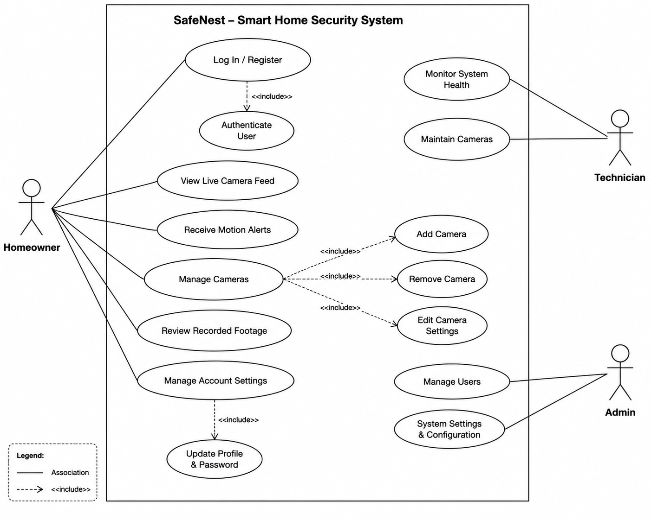

8. Technology Stack (Tentative)
Programming Language: Java
Framework: Spring Boot
Database: MySQL
Version Control: Git & GitHub
Hosting: Local / Cloud (optional)
Justification:
These technologies are widely used, beginner-friendly, and suitable for building scalable backend systems.

9. Risks (At least 3)

Risk | Likelihood | Mitigation

Unequal team contribution | Medium | Divide tasks clearly

Time management issues | High | Follow sprint plan strictly

Technical difficulties | Medium | Use simple technologies

Scope too large | Medium | Limit features early

10. Development Plan (High Level)
Sprint 1: Requirements + system design
Sprint 2: UI mockups + diagrams
Sprint 3: Final report + testing + improvements

11. Ethical & Social Considerations
The system handles personal security data such as camera feeds. Misuse of this data could lead to privacy violations. To prevent this, the system will use secure authentication and encrypted data storage. Access to video feeds will be restricted to authorized users only.

